**Basic Frappe Bench Commands**

This document outlines basic Frappe Bench commands and their usage, along with steps to capture the console output.

**Step 1: Start the Bench**

Command to start the development server:

bench start

This command initializes the Frappe development environment and displays real-time logs in the terminal.

**Steps to Capture Output:**

1. Open your terminal and navigate to the bench directory:
2. cd frappe-bench
3. Run the bench start command.
4. Take a screenshot of the terminal displaying the output logs.

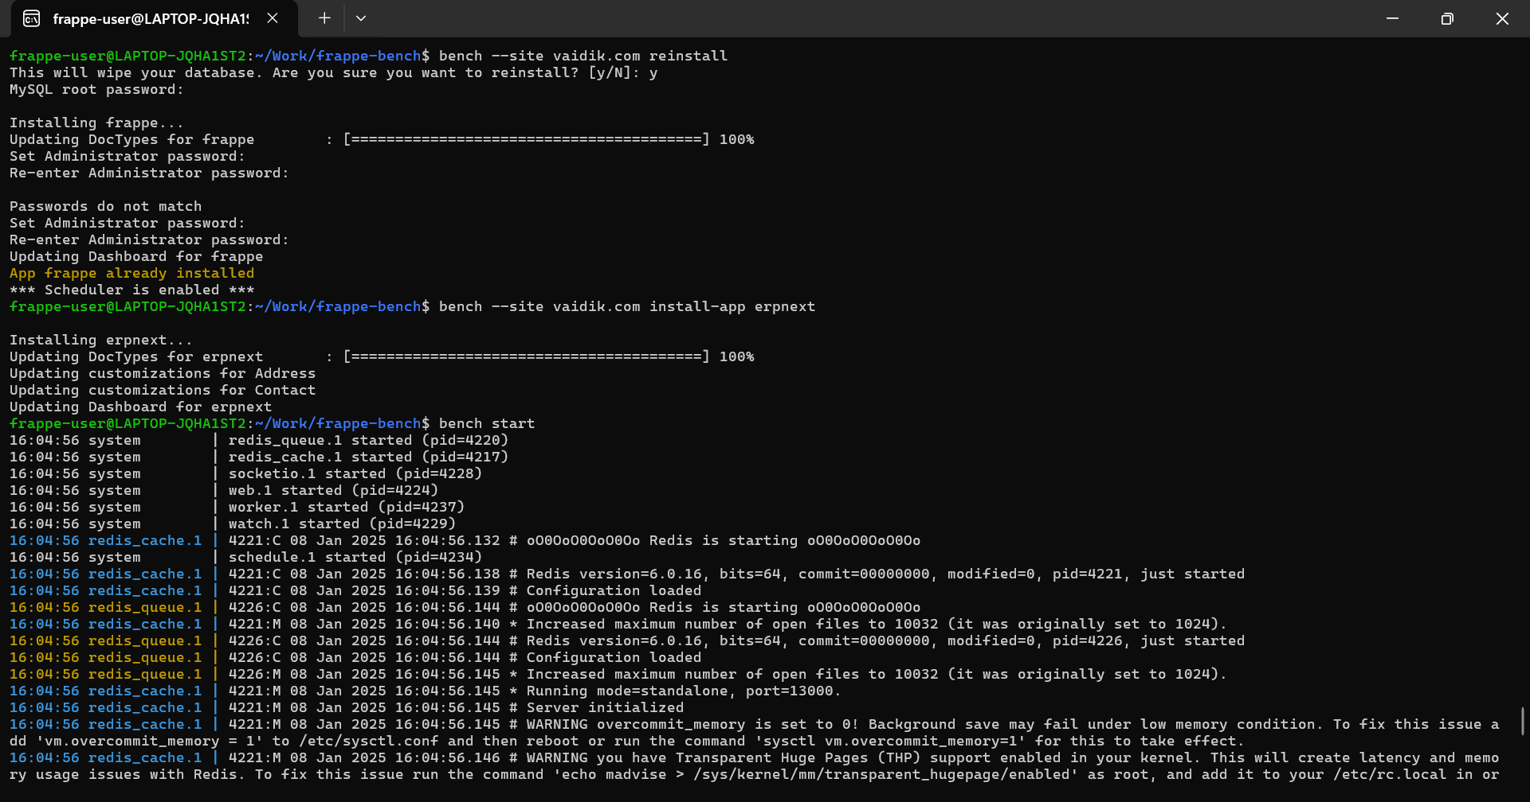

**Step 2: Create a New Site**

Command to create a new Frappe site:

bench new-site <site-name>

Replace <site-name> with the desired site name.

**Steps to Capture Output:**

1. Run the following command in the terminal:
2. bench new-site example-site
3. Follow the prompts to input the MySQL root password and other configuration details.
4. Once the site is created, take a screenshot of the terminal showing the confirmation message.

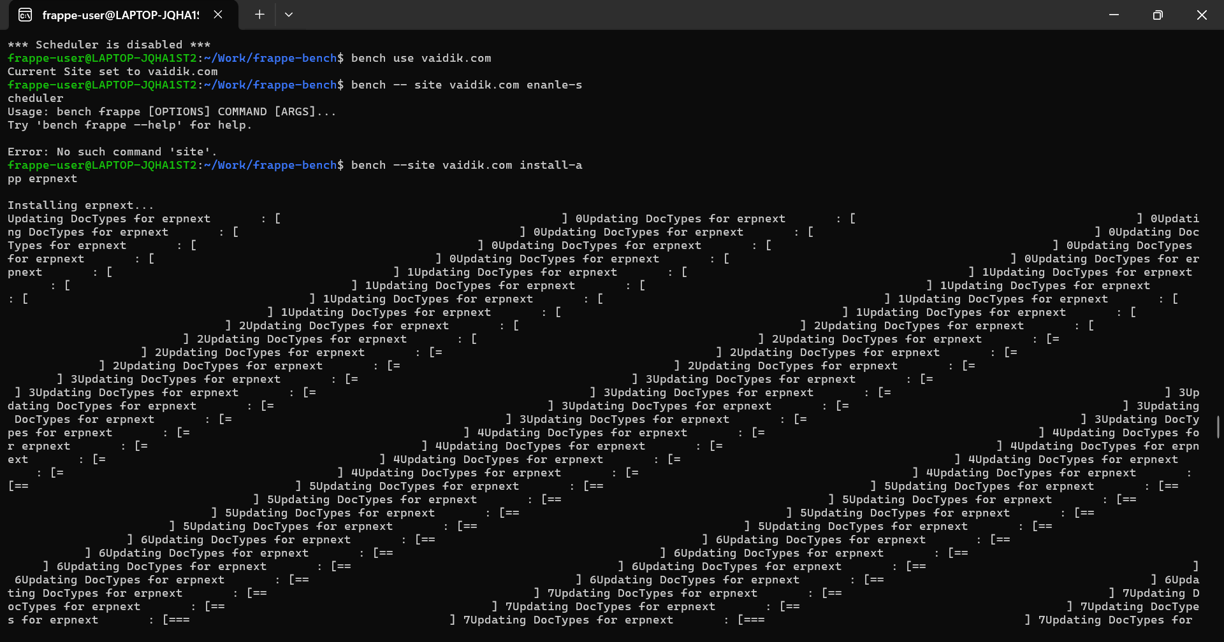

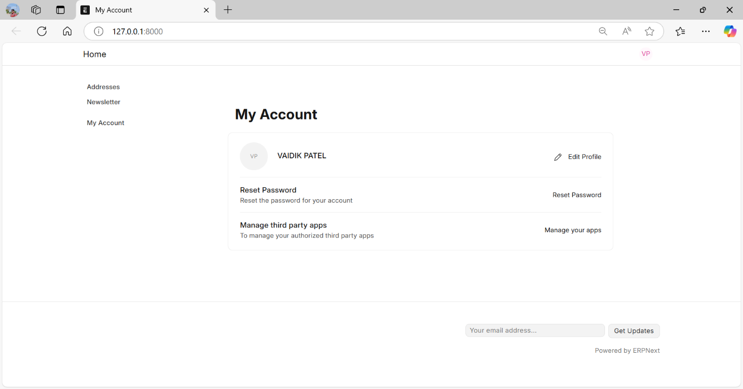

**Additional Commands**

Here are a few additional commands you may find useful:

**Check Installed Apps**

bench list-apps

This displays all apps installed in the current bench.

**Install a New App**

bench get-app <app-name> <app-repository>

Replace <app-name> with the desired app name and <app-repository> with its repository URL.

**Migrate Database Changes**

bench --site <site-name> migrate

Applies database migrations for the specified site.

**Backup a Site**

bench --site <site-name> backup

Creates a backup of the specified site, including database and files.

**Restore a Site from Backup**

bench --site <site-name> restore <backup-file-path>

Restores a site using a specified backup file.

**Update Bench and Apps**

bench update

Updates the bench environment and installed apps to the latest version.

**Restart Bench Services**

bench restart

Restarts the services managed by the bench.

**Check Bench Status**

bench doctor

Diagnoses common issues in the bench setup.